S T O L E N B I K E :

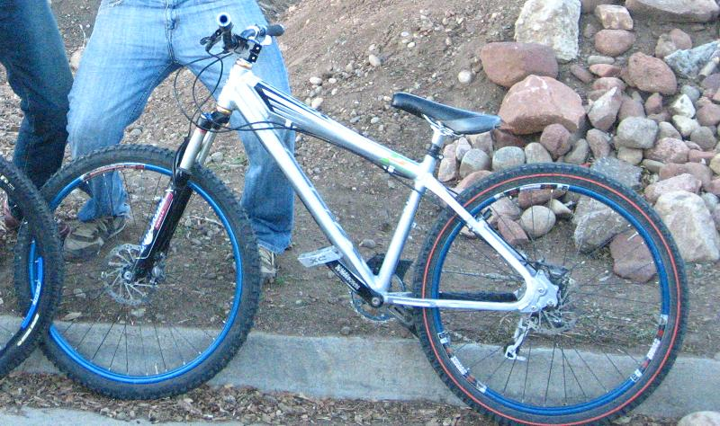

Bike was found missing on Monday February 26, 2007, but could have been taken before this date. Taken from a residence on 16th St. on the Hill in Boulder. Please read the parts list because there are some very distinct parts on this bike:

Frame: Silver Yeti Dirt Jumper, size: S
Fork: FOX RLC 125 (reduced to 80 mm)
Headset: Chris King (this headset is Gold, except the top dust cap is SILVER
Wheelset: Sun Rims BLUE singlewide, with ringlet BOLT ON hubs
Bar: Azonic Double Wall
Stem: KOOKA block (this is an old part and very distinctive to this bike)
Grips: ODI Lock-on with BLUE locks
Shifter: SRAM X-9
Deraileur: SRAM X-9
Cassette: SRAM X-9
Tires: Front is an old school Michelin and rear is a maxis semi-slick high roller
Seat: SDG Grand Prix (seat has a rip in the front that is covered by tape)
Crankset: RaceFace North Shore DH
Chainring: anodized BLUE 38t

PLEASE CALL (415) 336 - 4333 WITH ANY INFORMATION ABOUT THIS BIKE

